-------------------------------------------------------------------------------------------------------------------------------NAME: ARCHANA DEVI.P
REG NO: 192521192
COURSE: SOFTWARE TESTING
CODE: CSA0923
LAB PROGRAMS
26. Find the Largest Element in an Array Using JUnit
Aim
To write a Java program to find the largest element in an array and validate the result using JUnit test cases and white-box testing techniques.
Algorithm
- Start.
- Initialize an array of numbers.
- Assume the first element is the largest.
- Compare each remaining element with the current largest value.
- If an element is greater, update the largest value.
- Return the largest element.
- Verify the output using JUnit assertions.
- Stop.
Program: LargestElement.java
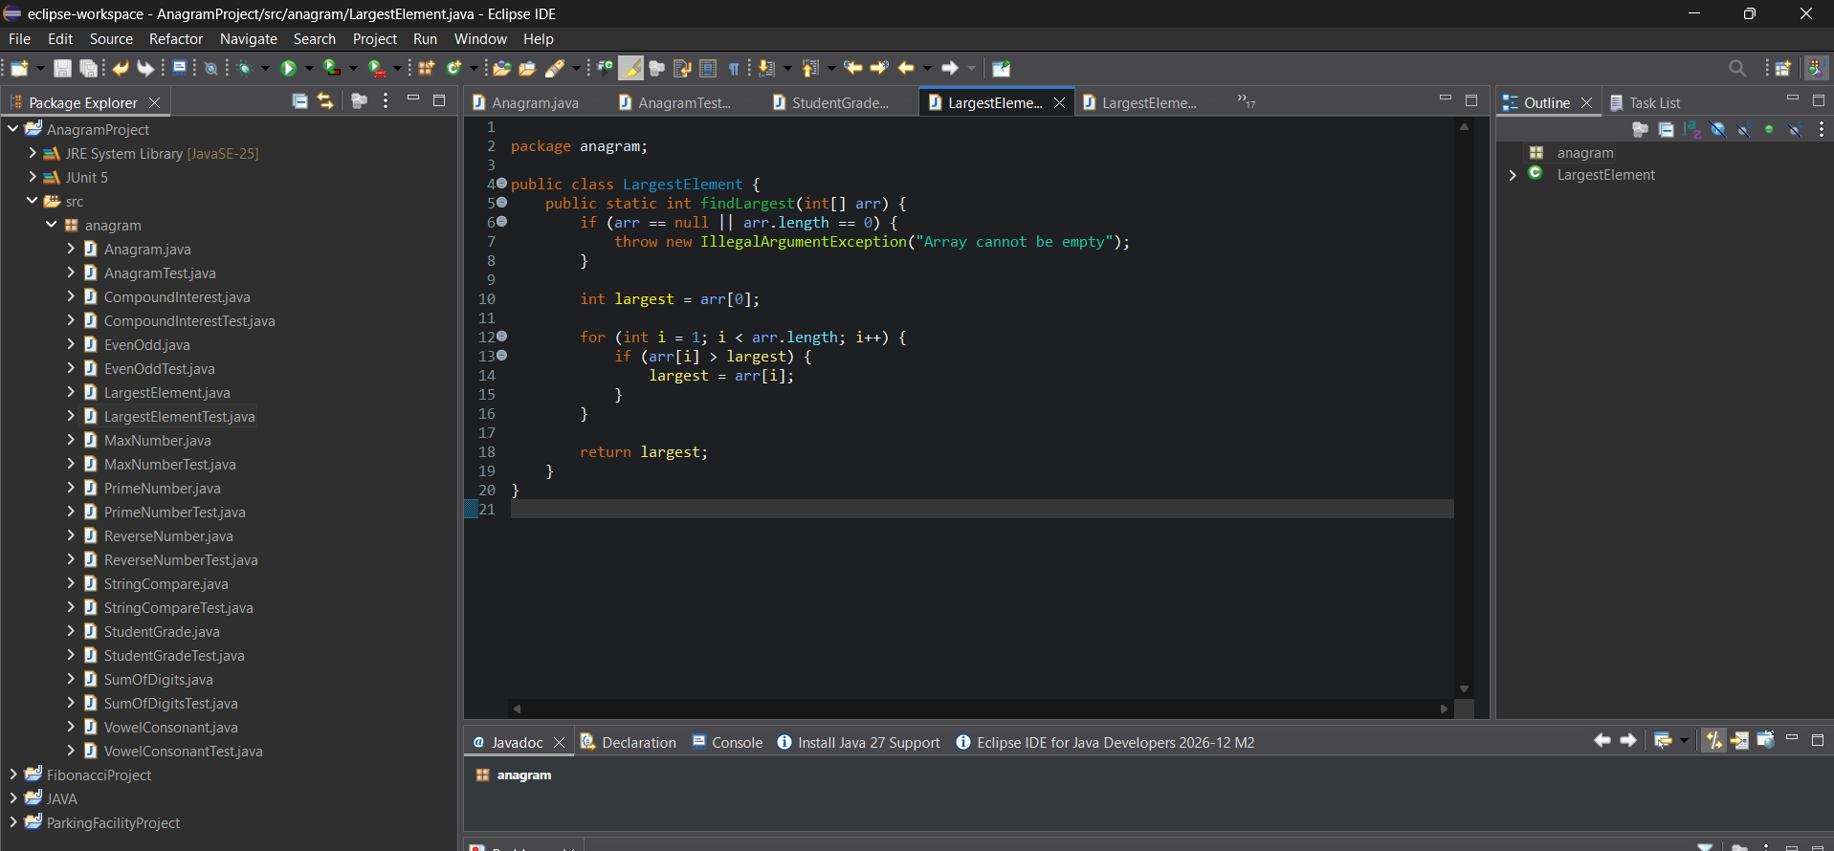
Junit Test:
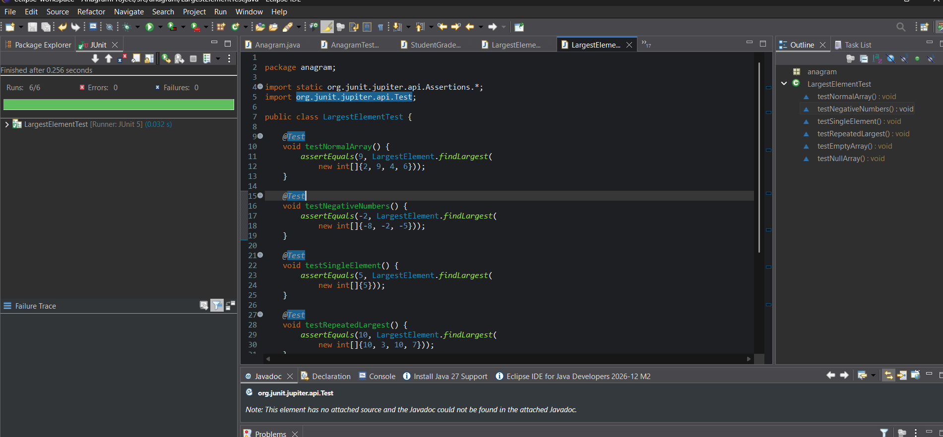
Result
The Java program to find the largest element in an array was implemented successfully. The output can be validated using JUnit 5 test cases and white-box testing techniques.

